Secure Code Review Report

Scaler Support Desk Assignment

Student Information
Field | Details
Student Name
Roll Number
Batch / Section
Email ID
Static Analysis Tool Used

Finding 1

Vulnerability Title
(Example: SQL Injection in Ticket Search Endpoint)

Classification
True Positive
False Positive

Justification
Explain why you classified the finding as a True Positive or False Positive.

Source File Information
Field | Details
File Name | app/services/preferences.py
Function Name | load_user_preferences()
Vulnerable Line Number(s) | 24-28
CWE (Optional) | https://cwe.mitre.org/data/definitions/89.html
Severity (Optional) | Low / Medium / High / Critical

Screenshot of SAST Tool Output (Full Scan Screenshot with timeline)
(Insert screenshot here)
Example:
- Semgrep Result
- SonarQube Finding
- Checkmarx Finding

Screenshot of Vulnerable Code
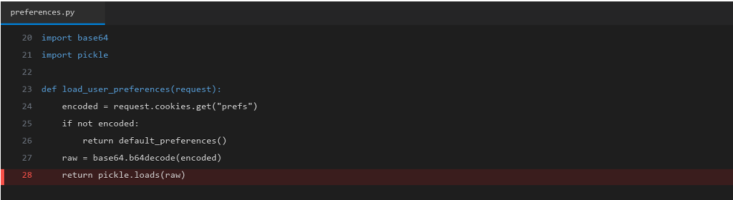
Requirements:
- Highlight the vulnerable line(s).
- Ensure the line numbers are visible.
- The affected code should be clearly readable.

Why is it Vulnerable?
Explain:
- Why the code is vulnerable.
- What coding mistake caused the issue.
- Why it is classified as a True Positive or False Positive.

Security Impact
Describe the possible impact if exploited.
Examples:
- Information Disclosure
- SQL Injection
- Authentication Bypass
- Remote Code Execution
- Privilege Escalation
- Denial of Service

Recommended Remediation
Explain how the vulnerability can be fixed.
Include secure coding recommendations where applicable.

References (Optional)
- OWASP
- CWE
- CVE (if applicable)
- Secure Coding Guidelines

(Duplicate this page for every additional finding.)

